CP ASSIGNMENT #1

URBAN NARRATIVES - HOW MY CITY SPEAKS TO ME!

I want you all to share ONE photograph, coupled with a brief write-up (Max word limit 300) – in the form of a power-point slide - that to you represents one aspect of the city’s public space that makes you think - causes you most concern, or alternatively gives u hope - a scene that speaks to you and tells you something about your public spaces – Public space could be a street/pavement, park or playground, waterfront, indoor space like a library or museum, a campus, markets and downtown.

The picture could represent some form of infrastructure or services related issue, encroachments, safety and security concerns, issues of exclusivity or inclusivity (example gender), the politics of space, environmental issues and space degradation, a merging of the private and public realm, innovation in design, coping mechanisms, depicting a particular profile/attitude/behavior of people or communities and related uses that may or may not conform to the ‘public space’ identity of the space.

You need to take the picture yourself!

Then tell us all what the picture reveals to you about your city – the people, the communities, role of the service providers, issues of legality and illegality, formality and informality – why the space stands the way you capture it through your lens?!

Final Submission Date: Sunday, September 28, 2025
You will be making a (3-minute max) presentation to the class on Tuesday, September 30, 2025– with just the picture and the write-up providing the backdrop to your talk!

Help us all know more about the city we live in!
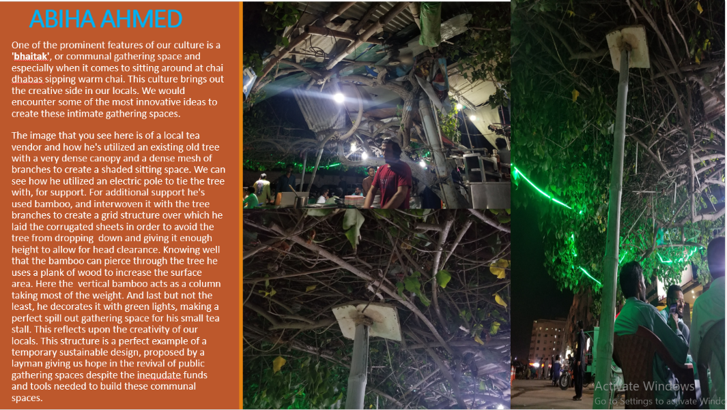
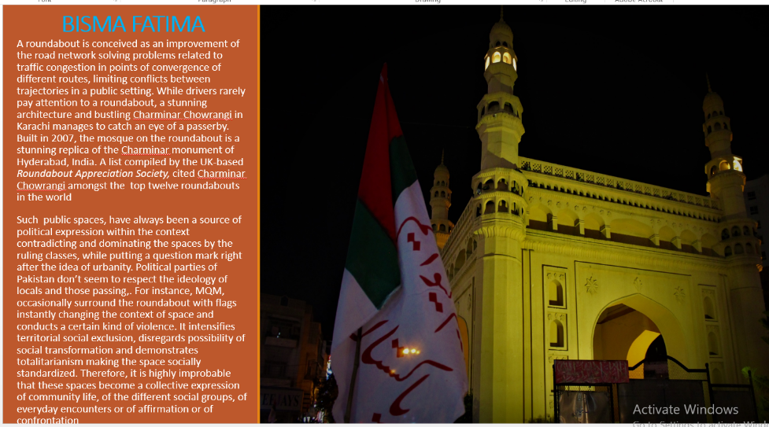
Sample Slides

